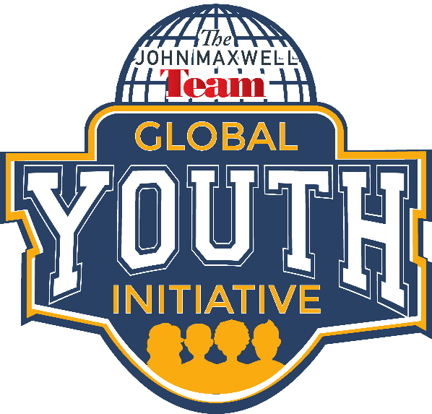
In 2017, the John Maxwell Team Global Youth Initiative was launched! Certified John Maxwell Team members from all around the world, hosted FREE events to equip youth with skills they need to serve as leaders in all areas of their lives.

WHY YOU WANT TO BE PART OF THE JOHN MAXWELL TEAM GLOBAL YOUTH INITIATIVE?
Today’s youth face many challenges – struggles with confidence, fear of failure, and bullying. As parents, teachers, and leaders, we can do something about it! You and your youth are invited to participate in a world-changing youth movement that will empower our kids to be the change they wish to see in the world!
During April and October of 2017, youth leadership events were hosted all over the world. John Maxwell Team members hosted 465,000 youth at nearly 2,000 events in 52 countries. Youth who attended these events were equipped, inspired, and empowered to have a positive self-image, respect themselves and others, be a positive influence, and fail forward toward success. The events were FREE and open to all children and youth groups, ages 8-18.
The Global Youth Initiative continues inspire change and initiate transformation in communities across the globe.

Do you want to be a part of the movement?

Join JMT Members like you and start adding value to youth in your community right now!

